This page describes the SVPHostFS solution. If you haven't already, please read the page describing how to add peripherals to the simulatorSVPHostFS makes it possible for applications running in the simulator to directly access files on your host PC. This is done by registering a new filesystem (svphostfs) with the file server. This fileserver uses a device driver that pass high level commands, like FileOpen, Seek to a peripheral "filesystem" device in the simulator.
The implementation of the filesystem is spit into different files;
- In the driver/ directory contains the kernel side logical device driver (LDD).
- In the fs/ directory contains the implementation of the filesystem classes and the user side device driver api class.
See figure for an overview of the different components and example functions calls.
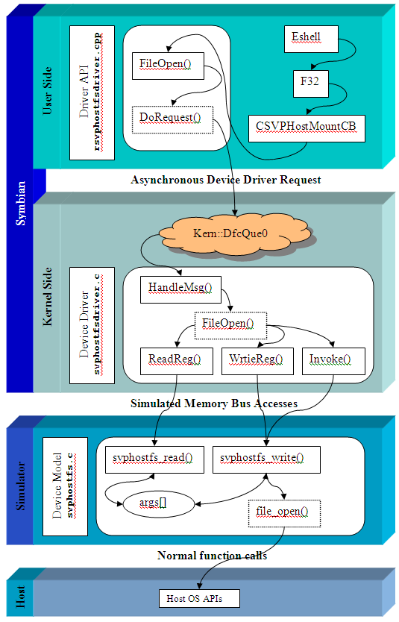
There are some limitations with the current implementation
- If you want to execute symbian .exe file that resides on the host filesystem, they must be placed in the sys/bin directory BEFORE you start the simualtor. The Symbian loader scans this directory once when the drive is mounted and will not do another scan.
- Be very careful when using the host filesystem and snaphots. Things might have happened to your local drive between the points you save and restore the snapshot.

